## Base Map

Select this plan type if you’re drawing a plan for a specific job site. It will let you display a site preview map, import aerial photos as the plan’s background and draw road networks automatically.

**Creating a New Plan from a Base Map:**

* Select **New Plan Wizard** in the Quick Start section of the Welcome to RapidPlan page.
* In **step 1**, select **Base Map**.
* In **step 2** enter your plan details and choose a print region and scale, or leave them as default.
* Scroll down to **Job Location** and type in the address for your job in the search bar and click **Search**.
* Select **Create Plan** and your plan will load on your canvas as shown in the image below.
* **Note**: in the Properties Palette you can change the provider of the map from omniscale, satellite and hybrid.
* 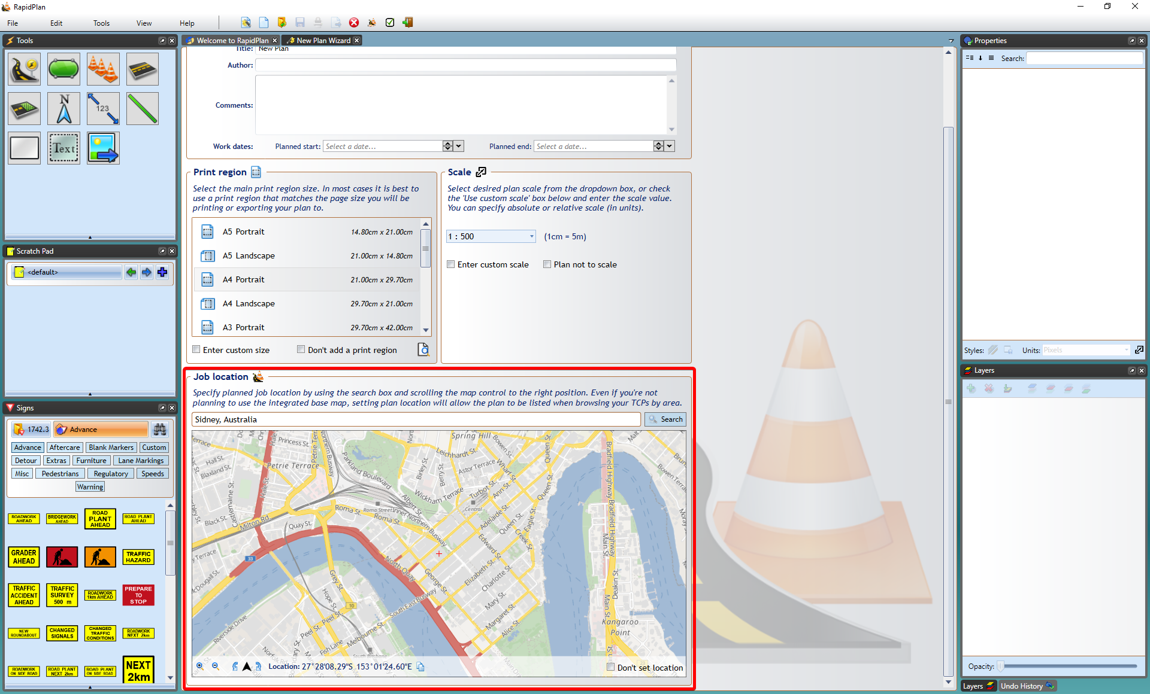
* Job_location_search
* 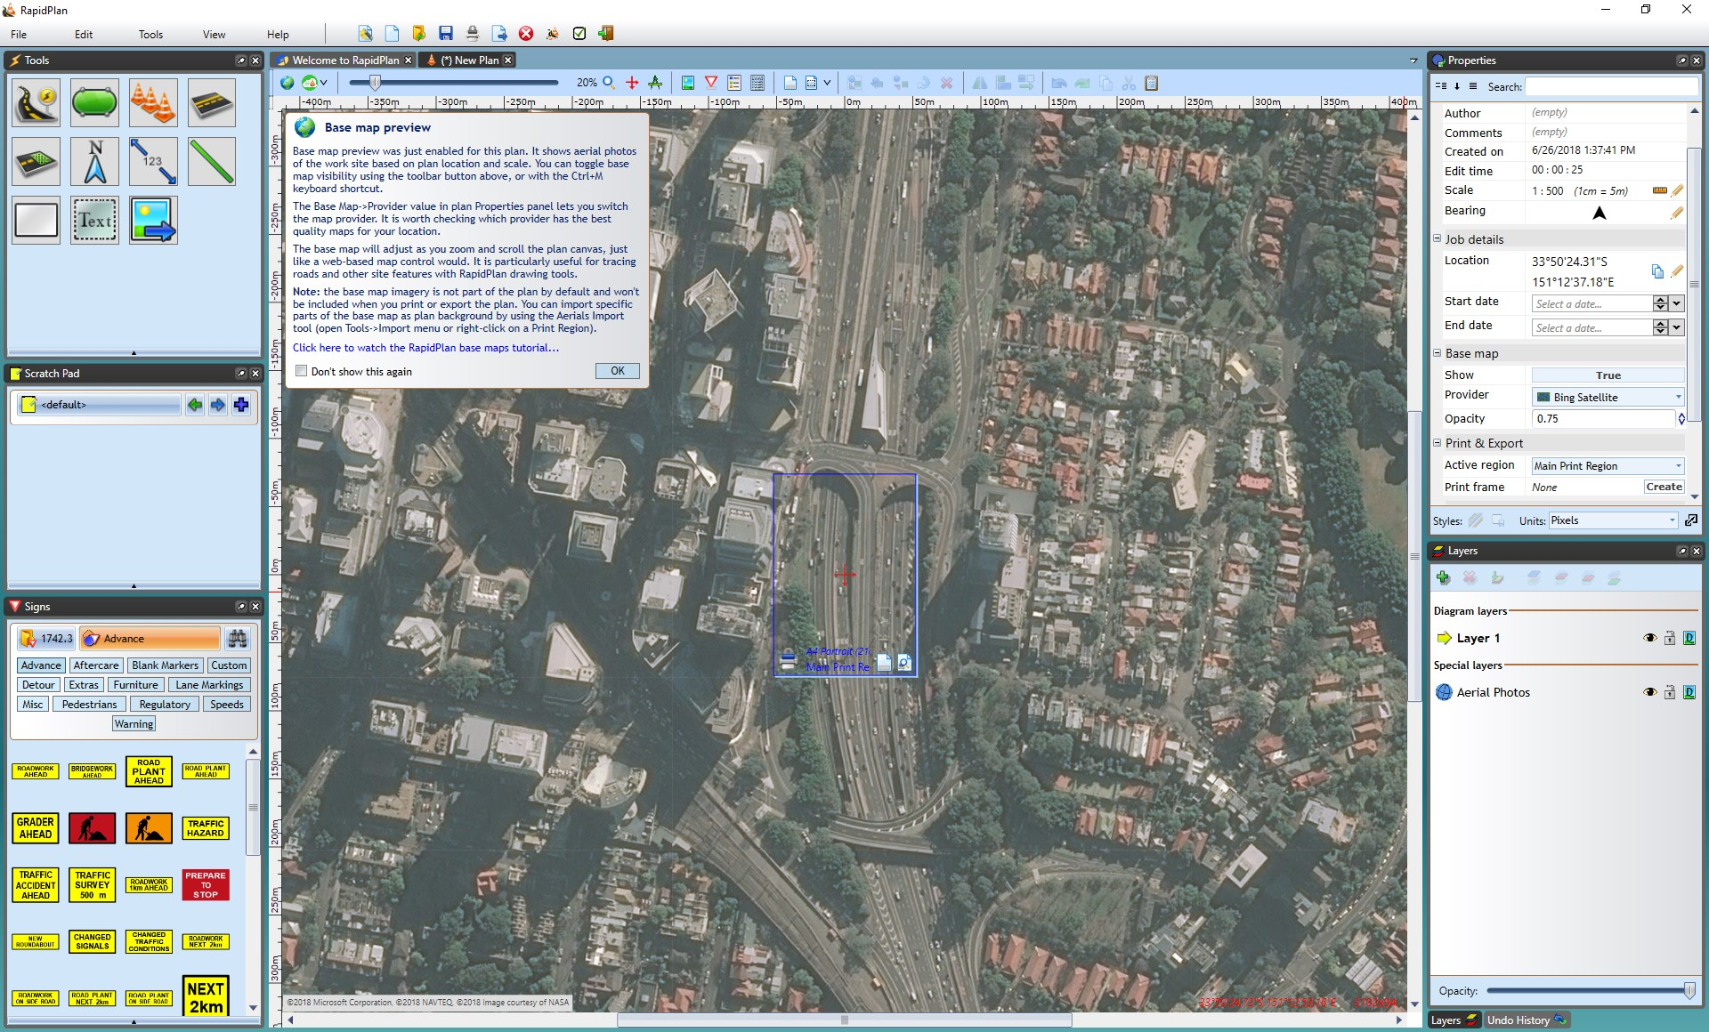
* Base_Map_Canvas

## Base Map Bearing

The bearing of a base map is adjustable, enabling you to draw plans at any orientation. To adjust the base map bearing: 1. Create a new plan in new plan wizard 2. Select the Base map plan type 3. When choosing job location, adjust bearing to liking as shown below.

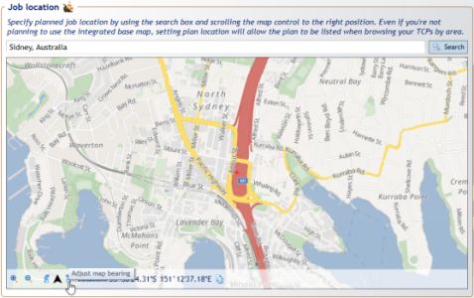

Base_map_bearing_adjustment

The base map bearing can also be adjusted in the properties tab on the right hand side once map has already been inserted into the plan as seen in the image below.

**Note:** To fine tune the bearing adjustment hold down the **CTRL** key and click and drag the mouse around on the map to get the desired position.

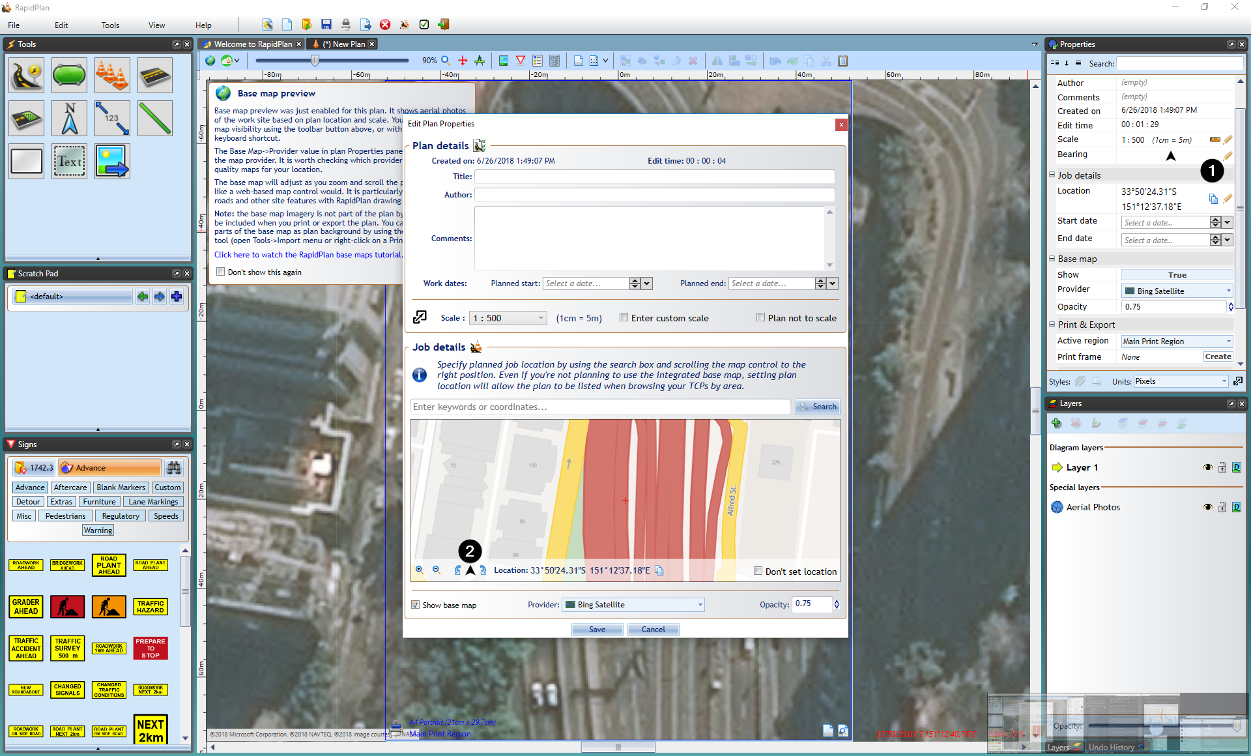

Base_map_bearing_properties